Part 3: Beyond Text
8. Multimodal -- Image & Audio
7 min -- give the AI a photo to read
Goal: Practice handing AI something that isn't text.
Needs: a photo on your device (a receipt, handwritten note, or whiteboard)
Image input: transcribe & summarize
Upload any photo of text, then paste this:
Daily:
Here's a photo of a handwritten note (or receipt). Transcribe
what it says. Keep the original wording. If a word is unclear,
mark it [unclear] and give your two best guesses.
Work:
Here's a photo of a whiteboard from a meeting. List the main
points as bullets, then list any action items you can spot.
Flag anything you couldn't read with confidence.
AI is great at the gist, weak on tiny detail -- always check totals and the bits it flagged.
Bonus: let the AI write an image prompt
Write me a detailed image-generation prompt for a cozy,
watercolor-style illustration of a cat reading a book by a
window, suitable for a greeting card. Then I'll paste it into
an image tool.
Write it down: What did the AI read correctly? What did it get wrong or flag?
Observation: The multimodal LLM demonstrated 100% accuracy by correctly transcribing every textual field from the bank receipt, including the Transaction ID, specific date (6/9/2026), and all names and amounts. It did not flag any text as unclear or misinterpret the formatting, showcasing its high proficiency in OCR (Optical Character Recognition) and its ability to process structured financial data without introducing hallucinations.
Takeaway: AI does the boring 90% (typing it out) so you focus on the careful 10% (checking what it flagged).

Uploaded Image
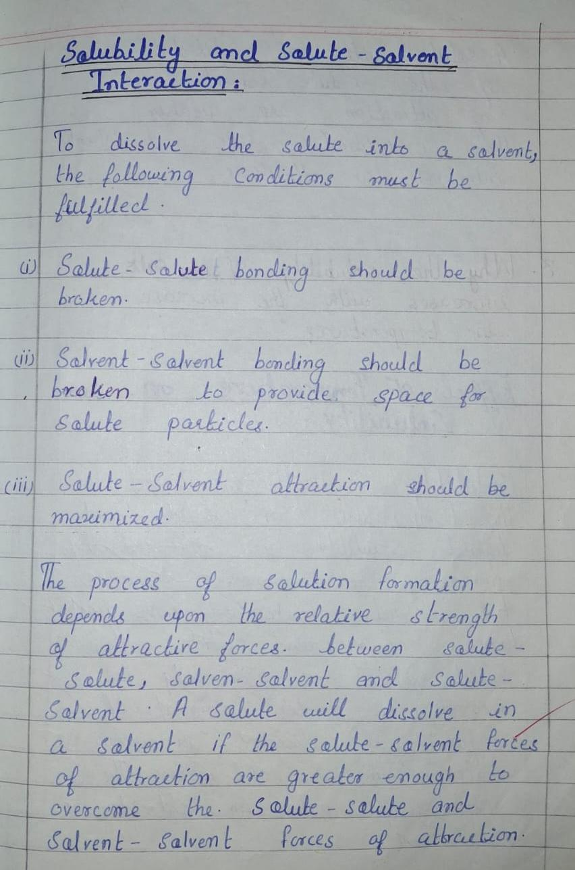

Chatgpt (Transcription)

Solubility and Solute-Solvent Interaction:
To dissolve the solute into a solvent, the following conditions must be fulfilled.
(i) Solute-Solute bonding should be broken.
(ii) Solvent-Solvent bonding should be broken to provide space for solute particles.
(iii) Solute-Solvent attraction should be maximized.
The process of solution formation depends upon the relative strength of attractive forces between solute-solute, solvent-solvent and solute-solvent. A solute will dissolve in a solvent if the solute-solvent forces of attraction are greater enough to overcome the solute-solute and solvent-solvent forces of attraction.

I didn't find any words that were too unclear to transcribe confidently, so I didn't need to mark any with [unclear].

